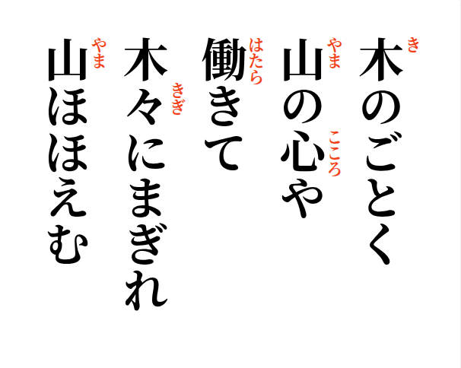

2026-08-31
Straight as a tree—
a mountain-gentle heart
working on
blending with the trees,
the mountain smiles

